**PROJECT REPORT**

**1.1 Overview**

**I have complete my project with my team. My topic is Vehicle Management System Using Salesforce this project have 7MILESTONES. As we move past each milestone, we get to know it better.**

**1.2 Purpose**

**You can see the project how much profit and traffic has come from our works. By looking at more details, you can improve your business by knowing more about how to maintain vehicles and what improvements need to be made.**

**2 PROBLEM DEFINITION & DESIGN THINKING**

**2.1 Data Model: Empathy Map**

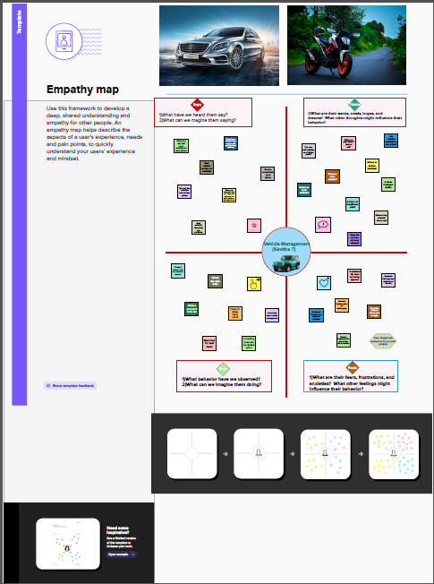

**2 PROBLEM DEFINITION & DESIGN THINKING**

**2.1 Data Model: Ideation & Brainstormimg Map**

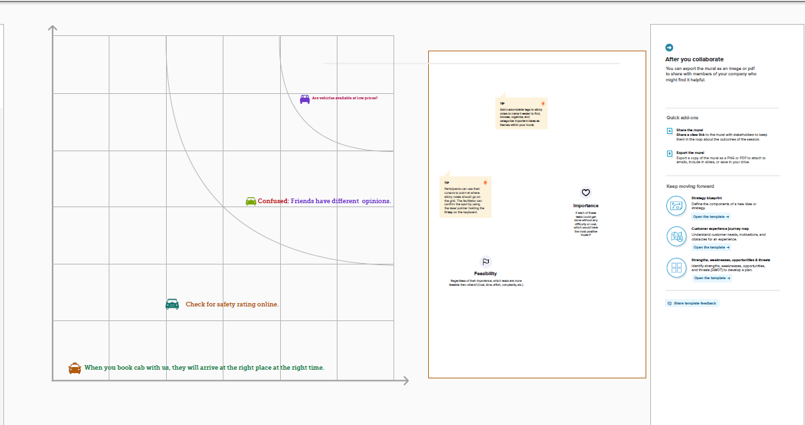

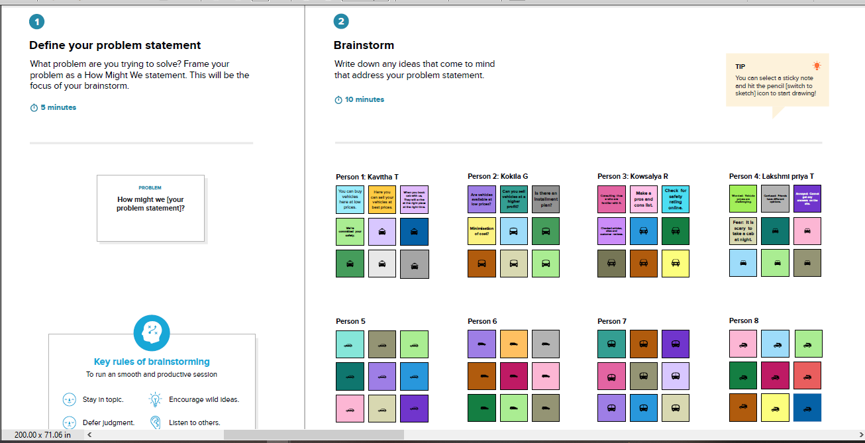

|  |  |
| --- | --- |
| **Object name** | **Field in the object** |
| **Obj 1** | |  |  | | --- | --- | | **Field Label** | **Data type** | | **CUSTOMER NAME** | **Text** | | **CUSTOMER MOBILE NO** | **Number** | |
| **Obj 2** | |  |  | | --- | --- | | **Field Label** | **Data type** | | **VEHICLE TYPE** | **Picklist** | | **CONDITION** | **Picklist** | |

3.2 **Activity & Screenshot:**

**MILESTONE 1:**

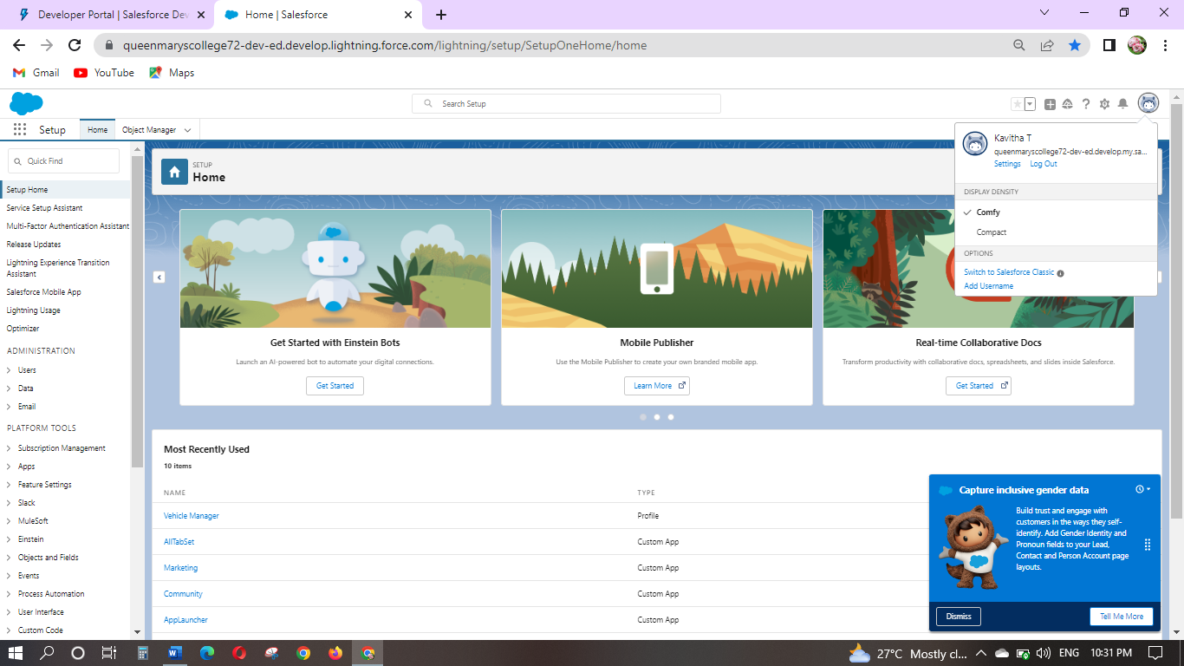

**MILESTONE 2:**

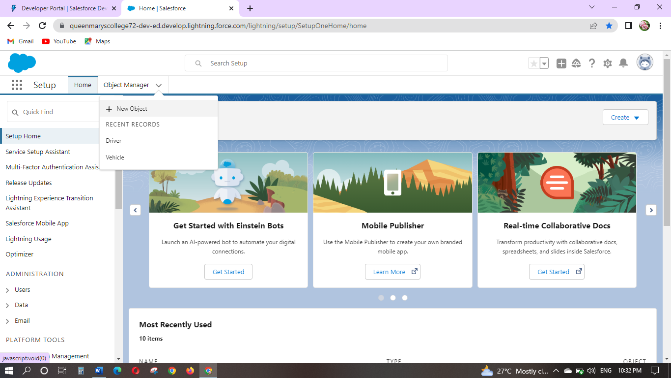

**MILESTONE 3:**

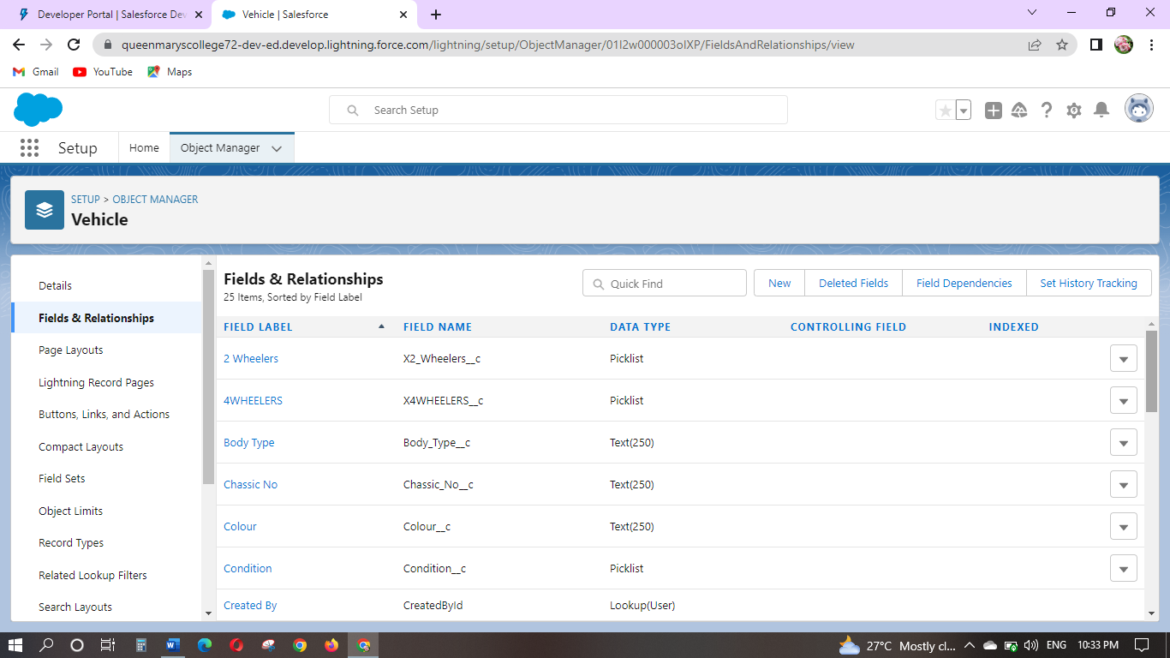

**ACTIVITY 2:**

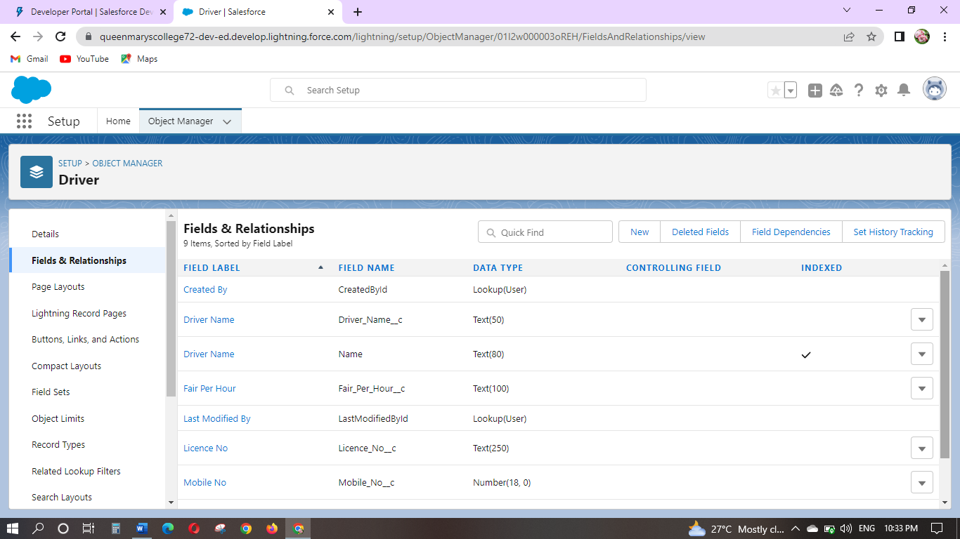

**MILESTONE 4:**

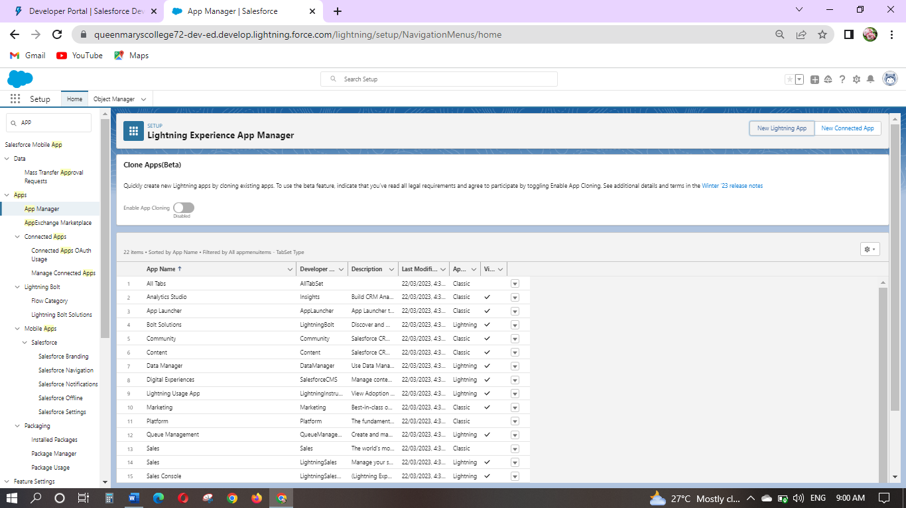

**MILESTONE 5:**

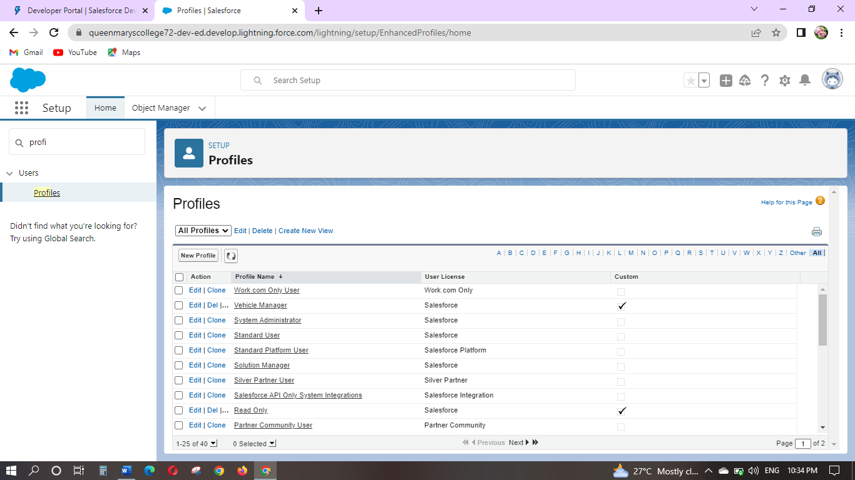

**MILESTONE 6:**

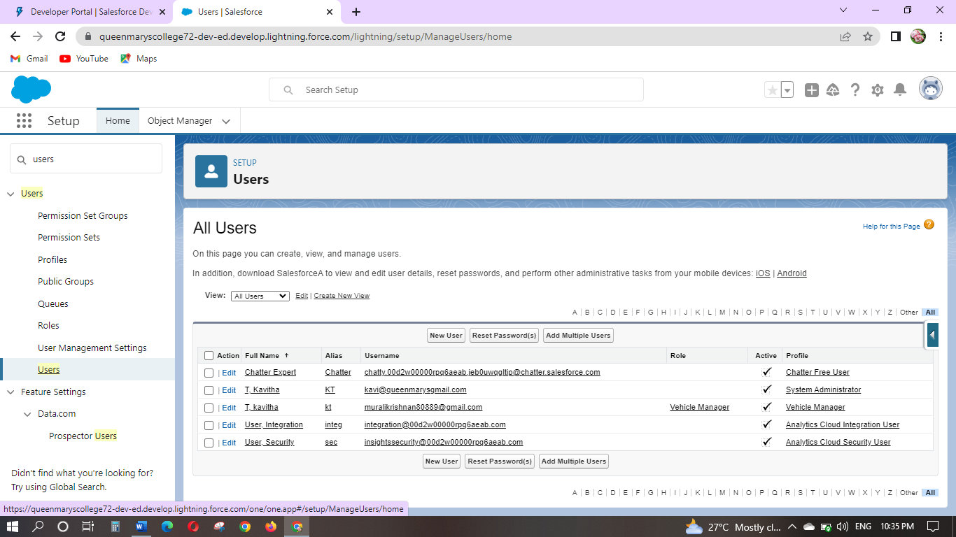

**MILESTONE 7:**

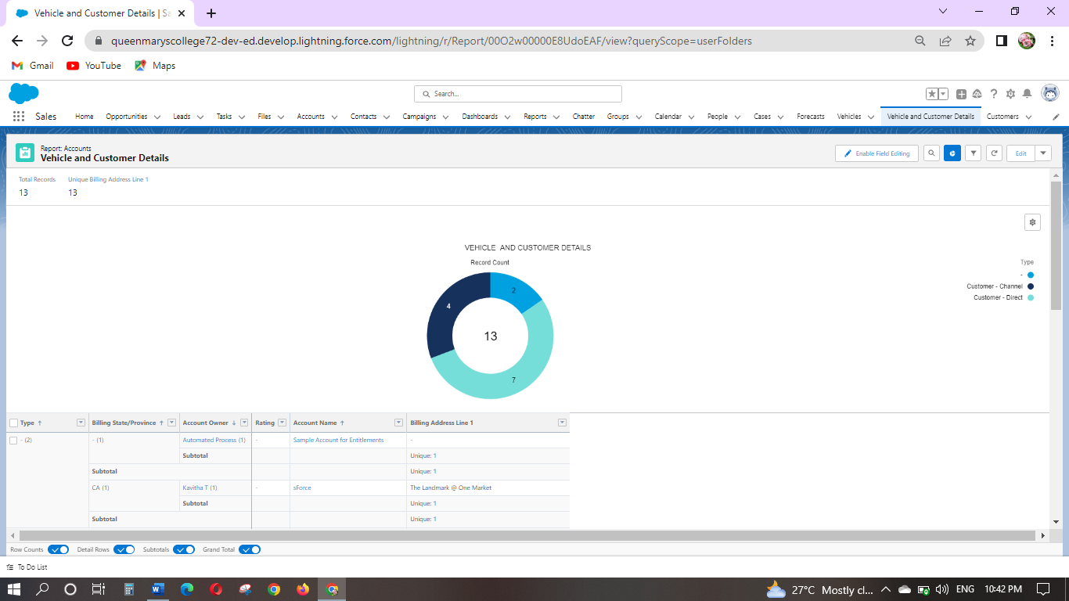

**ACTIVITY 2:**

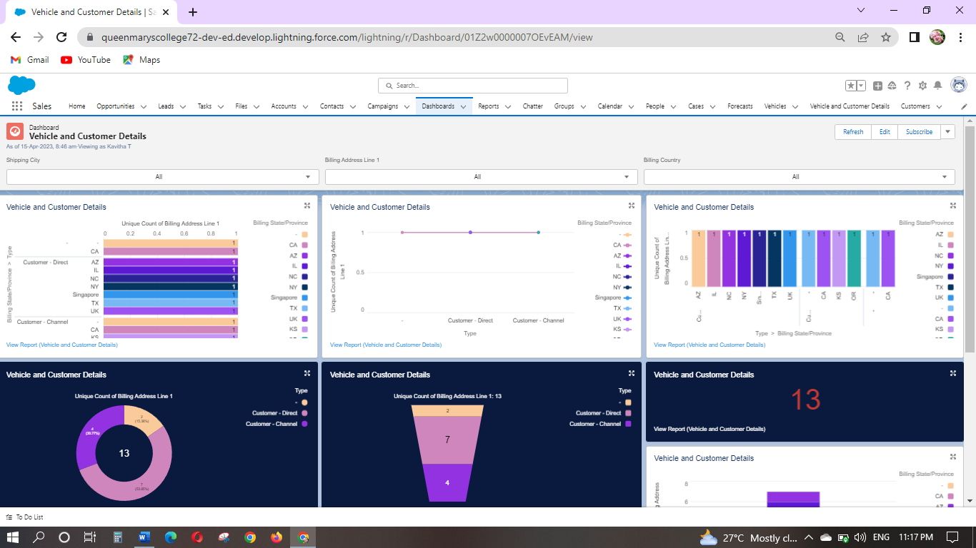

***ADVANTAGES & DISADVANTAGES:***

**ADVANTAGES:**

* + ***The projects are interesting,and useful for improve my computer knowledge.***
  + ***Salesforce team are actively reply on chat mantor option my doubts are clarified by salesforce team.***
  + ***This project dashboard are useful for profit,loss calculation easy to review.***

**DISADVANTAGES:**

***Many times system are busy and some option are not available ,there is no problem available in this website is always good***.

**APPLICATIONS:**

***Sales management and system tracking system are using for salesforce***

***Salesforce gives standard apps such as Sales Cloud, Call Center, Salesforce Marketing Cloud, and Community.***

**CONCLUSION:**

***Finally have complete my team project its very interesting and improve my knowledge.***

***FUTURE SCOPE:***

***Future is always on salesforce hand and future is job application system ,Vehicle management system usage projects are available for future.***

*************************************************************************************